ALGORITHM

The steps involved in building proposed model:

1. Data Collection: Collect a large dataset that includes historical admission data, including

student profiles such as PCM marks, and additional contextual factors such as race

(caste).

2. Data Preprocessing: Clean and process the data by removing duplicates, identifying

missing values, and encoding categorical variables.

3. Feature Selection: Identify the key predictors that could influence the admission decision.

4. Model Building: Apply machine learning algorithms and techniques (such as decision

trees, support vector machines, neural networks, regression models, etc.) to predict the

likelihood of a student getting admission.

5. Model Evaluation: Using a set of historical data, evaluate the model's accuracy and adjust

it based on the feedback.

6. Deployment: Once the model is refined and accurate, deploy it using streamlit to provide

personalized recommendations to incoming applicants based on their academic profiles.

7. Continuous Improvement: As new data becomes available, continue to refine the model

to improve its accuracy and ability to predict admission outcomes.

**MULTIOUTPUT CLASSIFIER**

Multi-output classification is a type of machine learning that predicts multiple outputs simultaneously. In multi-output classification, the model will give two or more outputs after making any prediction. In other types of classifications, the model usually predicts only a single output.

An example of a multi-output classification model is a model that predicts the type and color of fruit simultaneously. The type of fruit can be, orange, mango and pineapple. The color can be, red, green, yellow, and orange. The multi-output classification solves this problem and gives two prediction results.

In this tutorial, we will build a multi-output classification model using the tnea dataset. The model will classify the college code This will be the first output. The model will also classify the branch code as AI, The rating will be the second output. We will use Scikit-Learn MultiOutputClassifier algorithm to build this model.

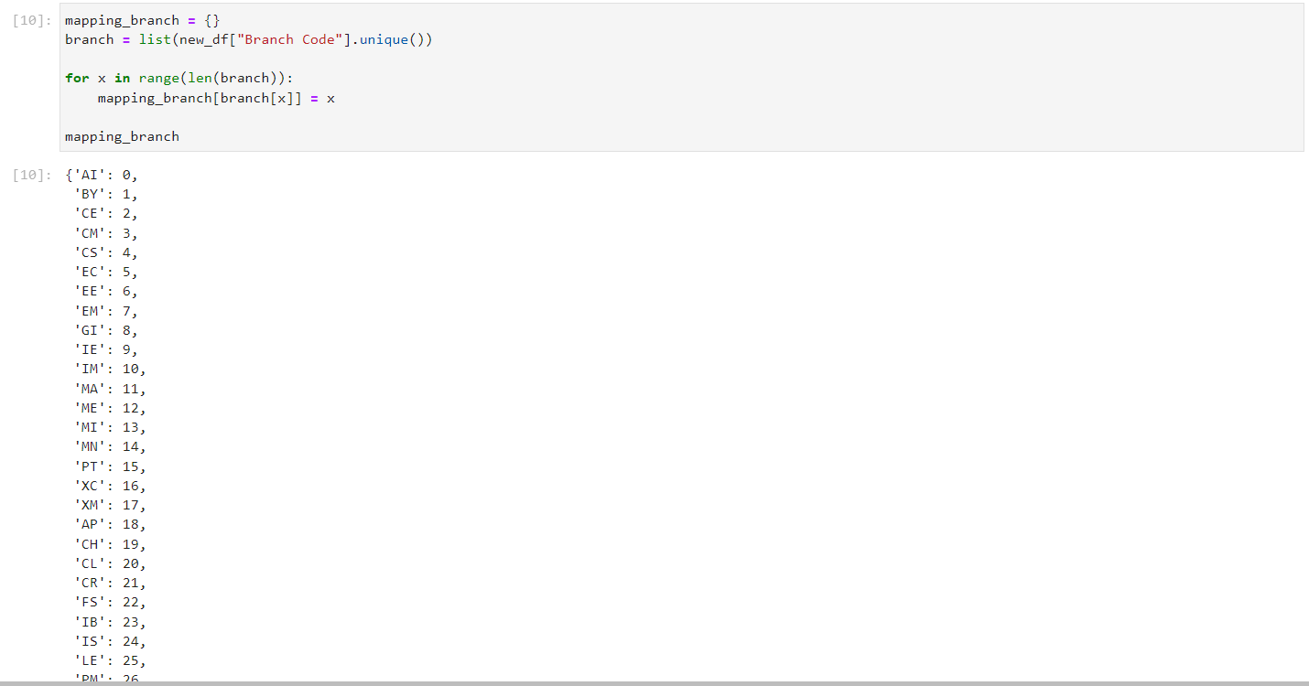

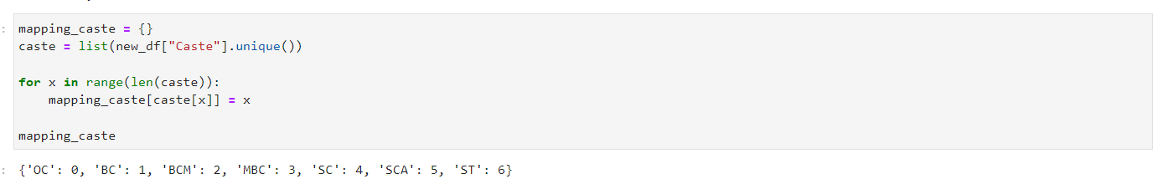

We used the DecisionTreeClassifier and MultiOutputClassifier algorithms to train the model.

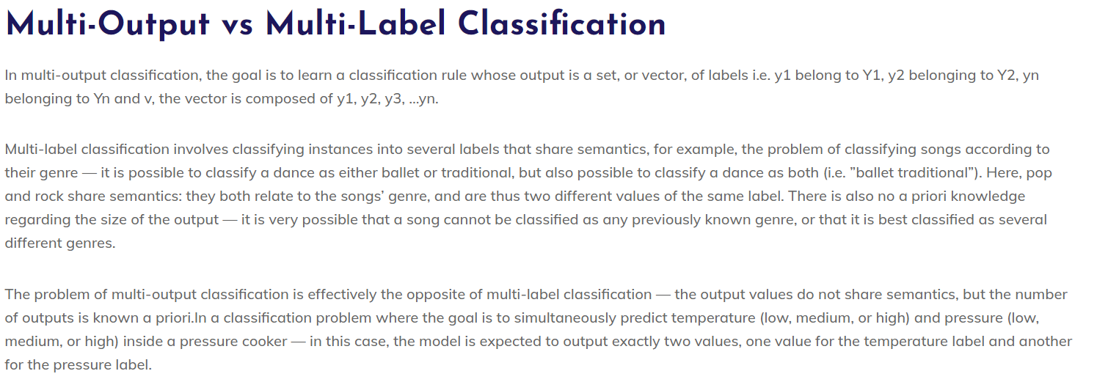

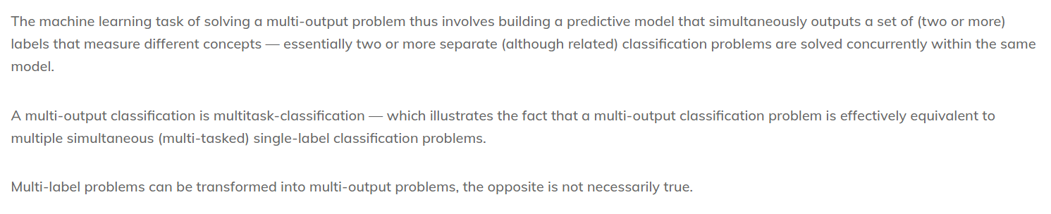

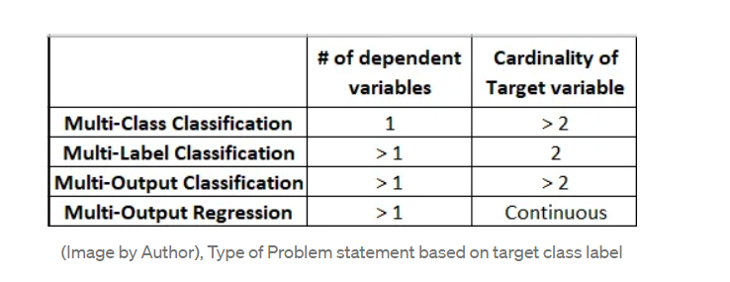

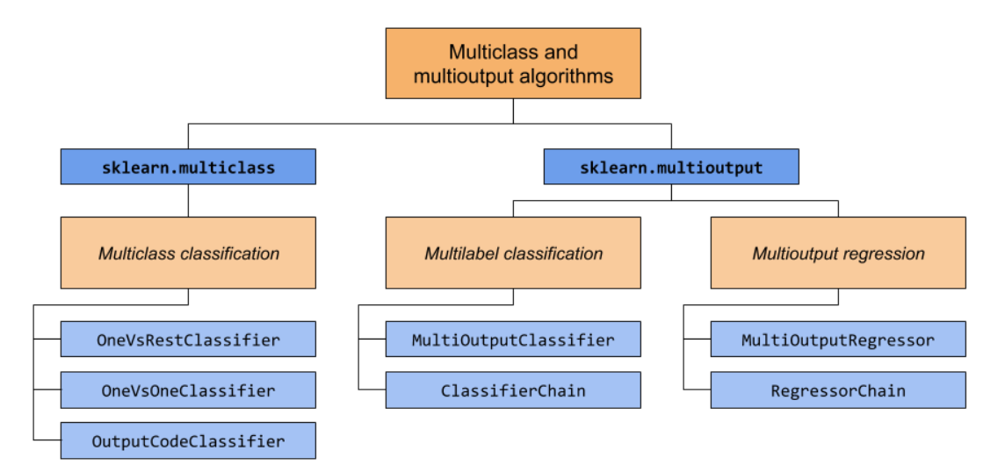

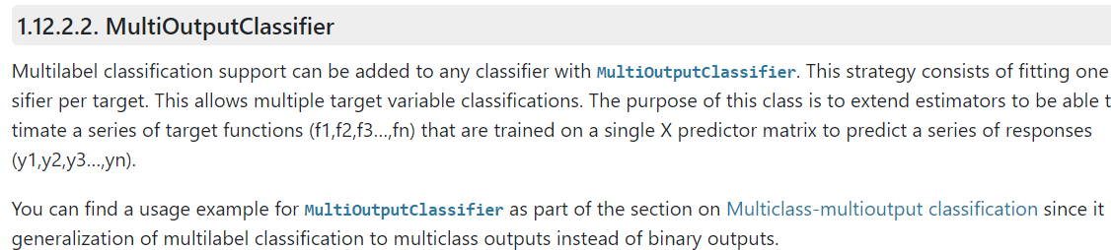

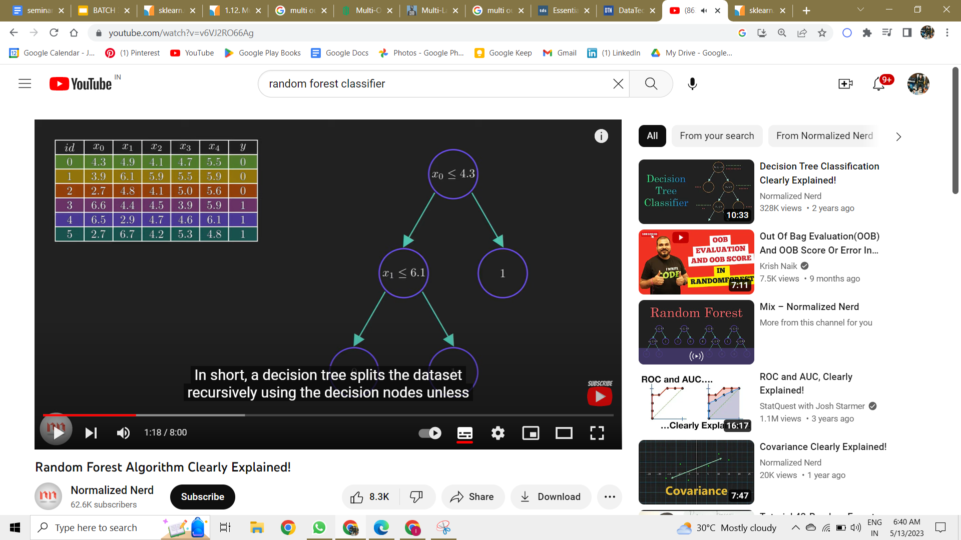

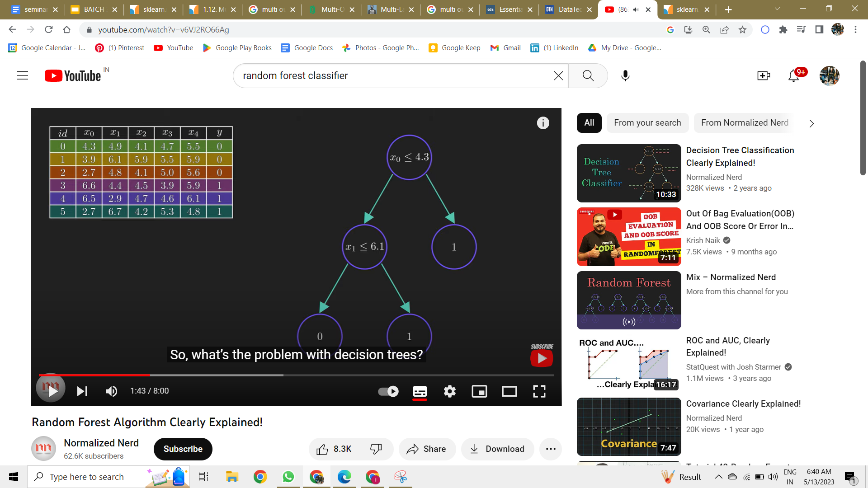

If training dta is changed, whole decision tree changes. Highly sensitive to training data.

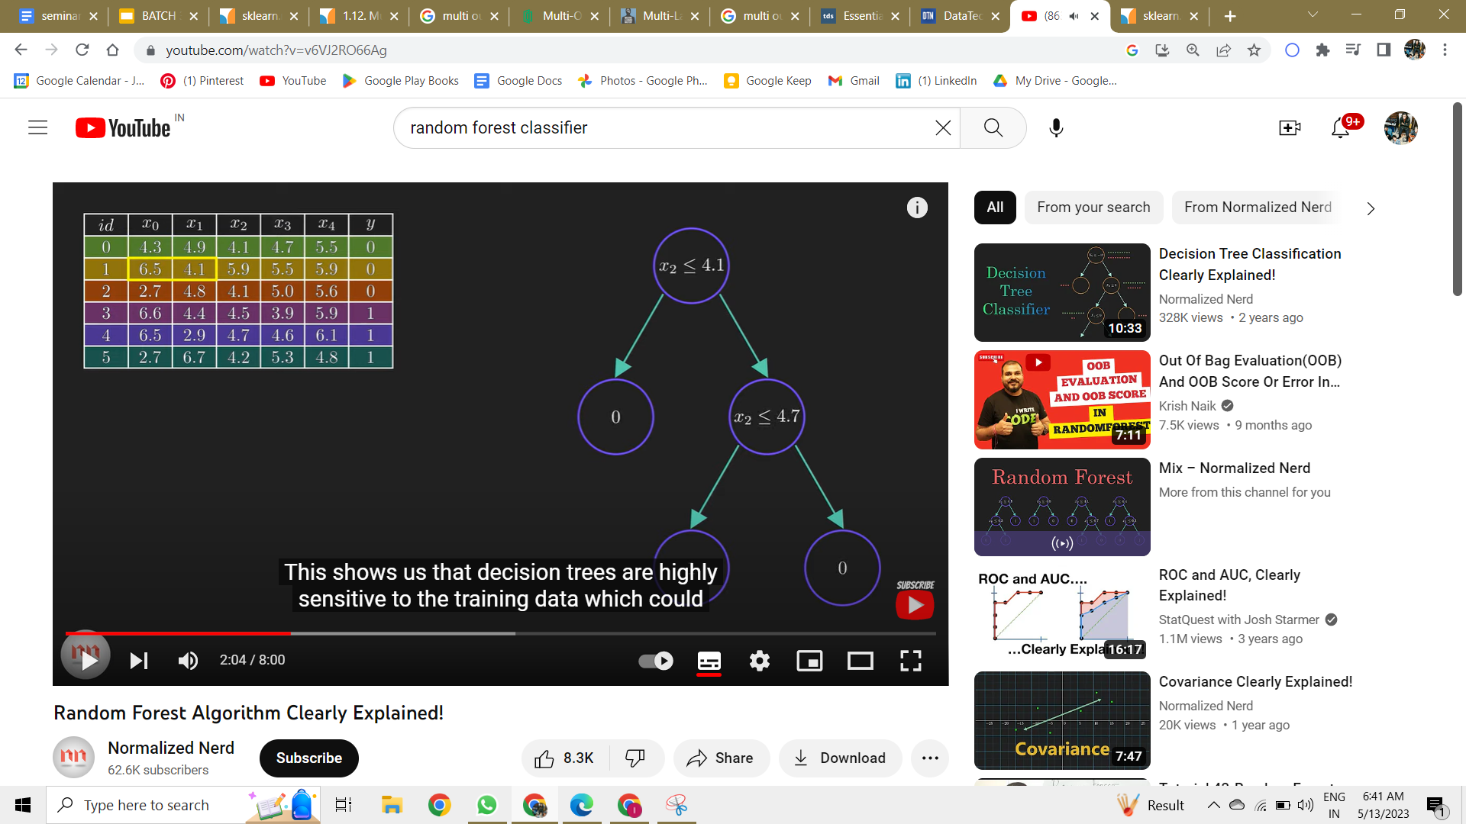

RANDOM FOREST  
